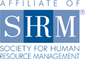
Meeting Notice: April 11, 2013
Flathead Valley Chapter of
Society for Human Resource Management

We are looking forward to seeing you at our upcoming meeting!
RSVP required. Please RSVP by NOON on Monday, April 8 to our Treasurer, Ronda Gress, at ronda@completerestorationllc.com. Please advise if you wish to order lunch or not when you RSVP.

Date: Thursday, April 11, 2013
Program: Tools for Growth Oriented Companies
Presenter: Kim Morisaki, Special Projects & Business Development, Montana West Economic Development
Kellie Danielson, CEcD, President, Montana West Economic Development
Time: 11:30 a.m. to 1:00 p.m. NOTE OUR MEETING TIME: Lunch will be served at 11:30 and our general meeting
will start at 11:45 a.m.
Place: Hilton Garden Inn, 1840 US Hwy 93 South, Kalispell
Lunch: MEMBER: No charge for members.
NON-MEMBER: $24 for program & lunch for non-members.
Note: If you RSVP for lunch and are unable to attend, you will still be billed for the lunch
(non-members only)

Program Description: Montana West Economic Development is a private non-profit organization that promotes economic diversity, job growth, and healthy businesses. In general, MWED provides business counseling; develops, submits, and administers grants; provides business loans; and provides demographics and economic data. The presentation will be focused on the tools managed and offered by Montana West Economic Development relative to Workforce and Employment: New Worker Training Resources, Existing Worker Training Resources, Resources to assist with purchasing equipment and lease cost, Agriculture related business resources, and Non-traditional Financing Resources.

Presenter Information: Kim Morisaki oversees Business Development and Special Projects at MWED, assisting new and expanding businesses in their pursuit of financial resources and business expertise. An active member of the Flathead Business Expansion and Retention team, Kim promotes entrepreneurship development through leadership roles for Flathead Area Young Professionals, and develops industry networks to encourage collaboration and knowledge sharing for local business sectors. Kim holds a degree in Politics, Philosophy and Economics from Claremont McKenna College.
Kellie Danielson, CEcD is a twenty-seven year veteran in economic development. Her role at Montana West & Flathead County Economic Development is “to foster jobs.” Kellie was designated as a “Certified Economic Developer”, or CEcD professional in 1995, recognizing her contributions to the profession. She is a graduate of the Economic Development Institute at the University of Oklahoma and the Community Development Institute at the University of Central Arkansas.

We encourage Flathead Valley Chapter members to bring guests to our monthly meetings to experience first hand, the benefit of SHRM. Members who bring guests will have an opportunity to win a lunch redeemable at a future meeting.

Support the SHRM Foundation and yourself — buy “Split the Pot” tickets! YOU could win money and/or lunch!

Visit our website at http://flathead.shrm.org/ for more information about our upcoming events and legislative updates!

We would also like to invite you to join our LinkedIn group:
http://www.linkedin.com/groups/SHRM-Flathead-Valley-Kalispell-Montana-4286381?trk=myg_ugrp_ovr.

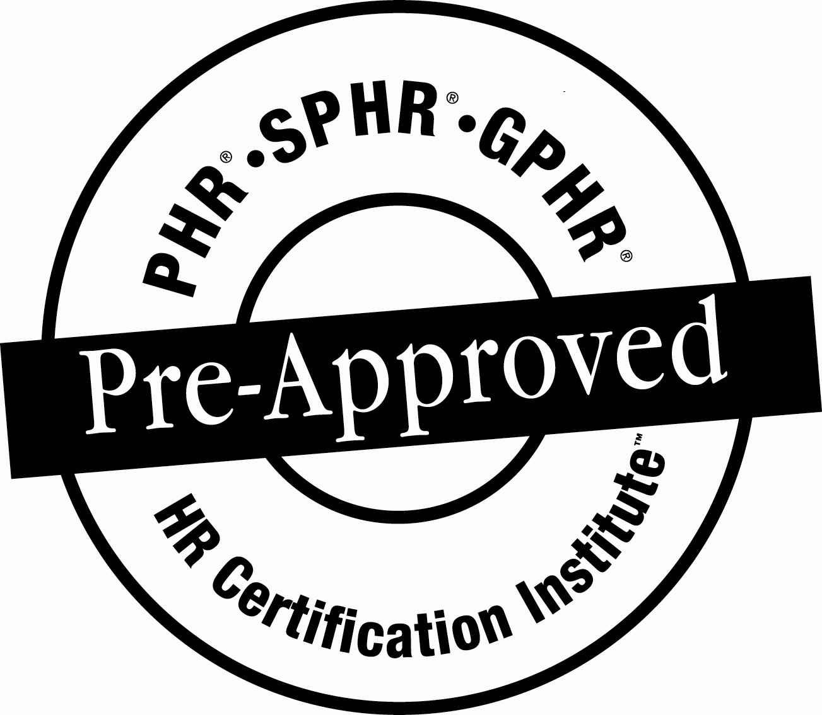
*The use of the HRCI Pre-Approved seal is not an endorsement by the HR Certification Institute of the quality of the program. It means that this program has met the HR Certification Institute’s criteria to be pre-approved for recertification credit.

